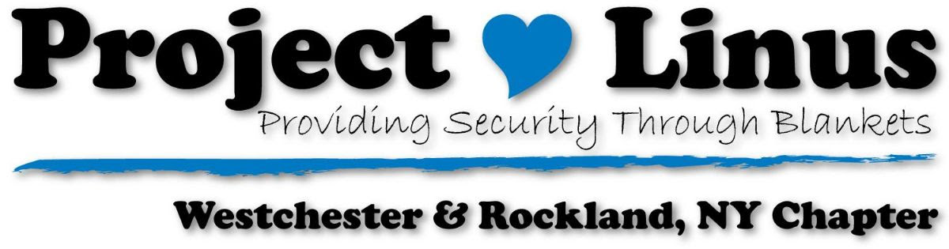

Time to Celebrate the Holidays – Twice this Month! ‘Tis the Season so join us at one, or both meetings:
ROCKLAND MEETING – DECEMBER 2, 2019
Join us on Monday, December 2nd at 9:30 for our last meeting of 2019.We will bid farewell to the decade and toast the new year. Our December meeting has the usual show and tell, and blanket labelling but we are also the beneficiaries of the never-ending talents of our blanketeers who bring in all sorts of goodies to make the morning even sweeter!
Everyone is invited and all treats are welcome as well. We will be meeting at 9:30 until about 10:15 or so, and we will be sharing our blankets and festivities on Facebook as well. Tune into the Westchester-Rockland Project Linus Facebook page at about 9:40 join us virtually, if you are unable to join us live.
WESTCHESTER MEETING – DECEMBER 14, 2019
Our Westchester blanketeers will come together to celebrate the season as well as label blankets on Saturday December 14th. Please note: We are changing locations for this meeting! Doris is our ever gracious facilitator but work being done is keeping her from hosting us this month, so we will be meeting at Adele’s house in New Rochelle/Scarsdale. Please email to let us know if you are coming, and/or if you need directions.
We will start our meeting at 9:30 and go until at least 11.
John C Hart Library Event
Thanks to the staff at the John C Hart Library for hosting, and to Marylou for organizing and running a great blanket-making event at the library. We were lucky to have a lovely display at the library for the entire month of November, and the event netted 53 blankets – 40 were made on Saturday and an additional 13 were dropped off in the days preceding the event. In addition, the library is now a drop-off site as well. Please email Marylou and/or Adele if you do leave blankets at the library so we can be sure to pick them up!
How Big, How Small?
We very often receive questions concerning the size of blankets. Remember that the blankets are donated to many different organizations and children. We deliver blankets to cover isolettes in the NICU as well as pediatric units and ERs so sizes can range from very small and on up. The blankets, whether knit/crochet, tied or quilted, are not necessarily meant to be on a bed, so there is no need to worry about making the “right size”.
Thank You Notes Received
We have the most generous, energetic, creative group of blanketeers who donate their time, energy and money to simply make a child happy. While no thank-you is needed, sometimes it is nice to see how Project Linus positively impacts a child and a parent. Here are some thank you notes we received or were received by other chapters:
Hello! My twins spent time in the NICU and when they were released to us they had the most beautiful blankets! They are now 6 months old and their project Linus Blankets are still their favorite:) just wanted to say thank you and we really enjoy them :)
Thank you for being such sweet blessings! Your blanket meant so much to our daughter during her hospital stay. You are true angels! God bless!!
February 15th is National Make-A-Blanket Day
We are in the planning stages for events to be part of this National Day. Please look for information on our Facebook Page as well as next month’s newsletter. We can use help on the 15th so mark your calendars! We are looking at events to be held:
Rockland
Joann Fabrics Peekskill
Joann Fabrics Scarsdale

Youtube
If you have not done so already, please check out our Youtube page and subscribe. Thanks to Arlette we have some beautiful videos of our Westchester meetings as well as some of our events. There are great pictures of some of the outstanding blankets created by our blanketeers – the videos are sure to inspire! Please tell your friends to subscribe as well!
WISHING OUR BLANKETEERS ALL THE JOY OF THE SEASON AND HEALTH AND HAPPINESS IN THE NEW YEAR
Adele Shapiro AdeleShapiro41@aol.com
Doris Smith Momdsmith1@yahoo.com
Ruthie Wilson billruth4@verizon.net
Joanne jo3291@aol.com
MaryLou mlbmsantoro@yahoo.com

Visit us at Westchester-RockandProjectLinus.org

